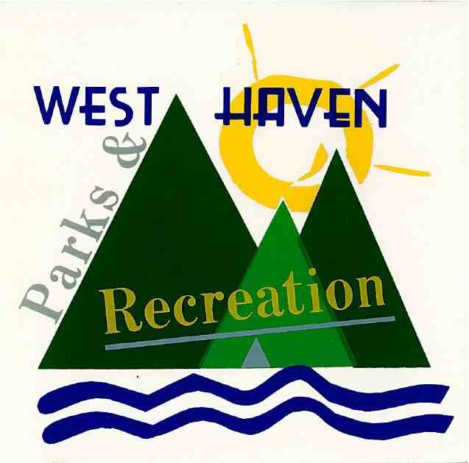

West Haven Parks & Recreation –Summer Fun Boys Basketball League

Code of Conduct

To ensure a safe, respectful, and enjoyable environment for all participants, spectators, and staff, the following rules will be enforced throughout the season. All players and families are expected to read and adhere to this Code of Conduct.

### **PLAYER CONDUCT**

* Show respect for teammates, opponents, coaches, referees, and spectators at all times.
* No physical altercations, taunting, threats, or bullying of any kind.
* Follow all referee and coach instructions without argument.
* No inappropriate or offensive language.
* No destruction or misuse of league or facility property.
* No use or possession of tobacco, vapes, alcohol, or drugs.
* No inappropriate use of social media toward participants or staff.

Misconduct on or off the court may result in suspension or removal from the league without refund.

### **PARENT & SPECTATOR CONDUCT**

* Maintain a positive and supportive environment.
* Harassment or verbal abuse of referees, coaches, players, or other spectators will not be tolerated.
* No profanity, threats, or inappropriate gestures.
* Coaching from the stands is not allowed.
* Spectators must stay off the court and bench areas at all times.
* Any parent or spectator who violates these rules will be asked to leave and may be banned from future games.
* Please ensure that all children in attendance are supervised by a parent or guardian at all times.

### **FACILITY & SAFETY RULES**

* Children may not bring Nerf guns, air pellet guns, or similar toys to games. Anyone with these items will be asked to leave the area.
* Keep the facility clean and respect common areas.
* No loitering, vandalism, or disruptive behavior inside or outside the facility.
* Only players and coaches allowed on the court.

### **VIOLATIONS**

Consequences may include:

1-Verbal or written warnings

2-Game removal

3-Suspension from future games

4-Permanent dismissal from the league (no refund)

Thank you for doing your part to make this a positive, safe, and successful season!

West Haven Parks and Recreation