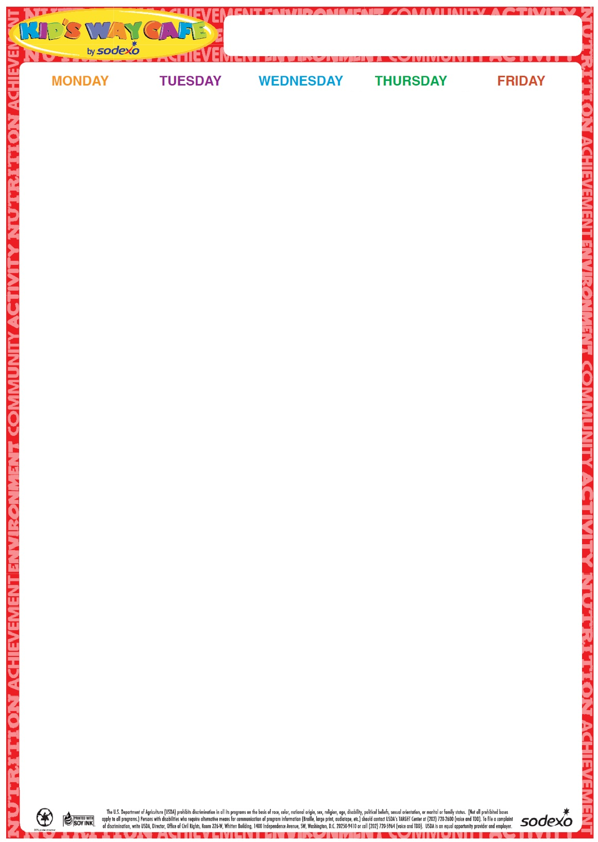

22

Cheeseburger on a Roll

Baby Carrots and ranch dip

Fruit

Milk

**23** Hot Dog on a Roll Broccoli Florets w/Dip

Fruit Milk

**24** Turkey and Cheese on a Grinder

Three Bean Salad

Fruit

Milk

**25**

Chicken Patty on a Roll

Carrots and Dip

Fruit

Milk

**26**

Cheese Pizza

Garden Salad

Fruit

Milk

**Milk offered Daily-Chocolate or White**

29

Hot Dog on a Roll

Potato Chips & pickles

Corn

Fruit

Milk

**30**

Chicken Salad Sandwich w/Buffalo Sauce on the side

Teddy Grahams

Baby Carrots w/Dip

Fruit

Milk

**31**

Chicken Nuggets

Goldfish crackers

Apple Slices

Roasted Chickpeas

Milk

**1**

Hamburger on a Roll

Tater Tots Steamed Vegetable Fruit Milk

**2**

Cheese Pizza

Garden Salad

Fruit

Milk

**Milk offered Daily-Chocolate or White**

5 Grilled Cheese Sandwich

Tomato and Cucumber Salad

Fruit

Milk

**6**

Italian Combo Grinder

Chips

Pickles

Fruit

Baby Carrots

Milk

**7**

Turkey and Cheese Sandwich on a Roll

Steamed Broccoli Fruit

Milk

8

Chicken Patty on a Roll

Carrots and Dip

Fruit

Milk

**9**

Cheese Pizza

Garden Salad

Fruit

Milk

**Milk offered Daily-Chocolate or White**

**12**

Fried Dough with Marinara Sauce and 2 Mozzarella Sticks

Cherry Tomatoes

Fruit

Milk

13 Egg, Bacon and Cheese on a Bagel

Tater Tots

Fruit Milk

14

Chicken and Cheese Quesadilla

Salsa

Corn and Black Beans

Fruit

Milk

**15**

Cheeseburger on a Roll

Cucumber and Tomato Salad

Fruit

Milk

16

Cheese Pizza

Garden Salad

Fruit

Milk

**Milk offered Daily-Chocolate or White**

**2024**

**July/Aug**

Summer Menu