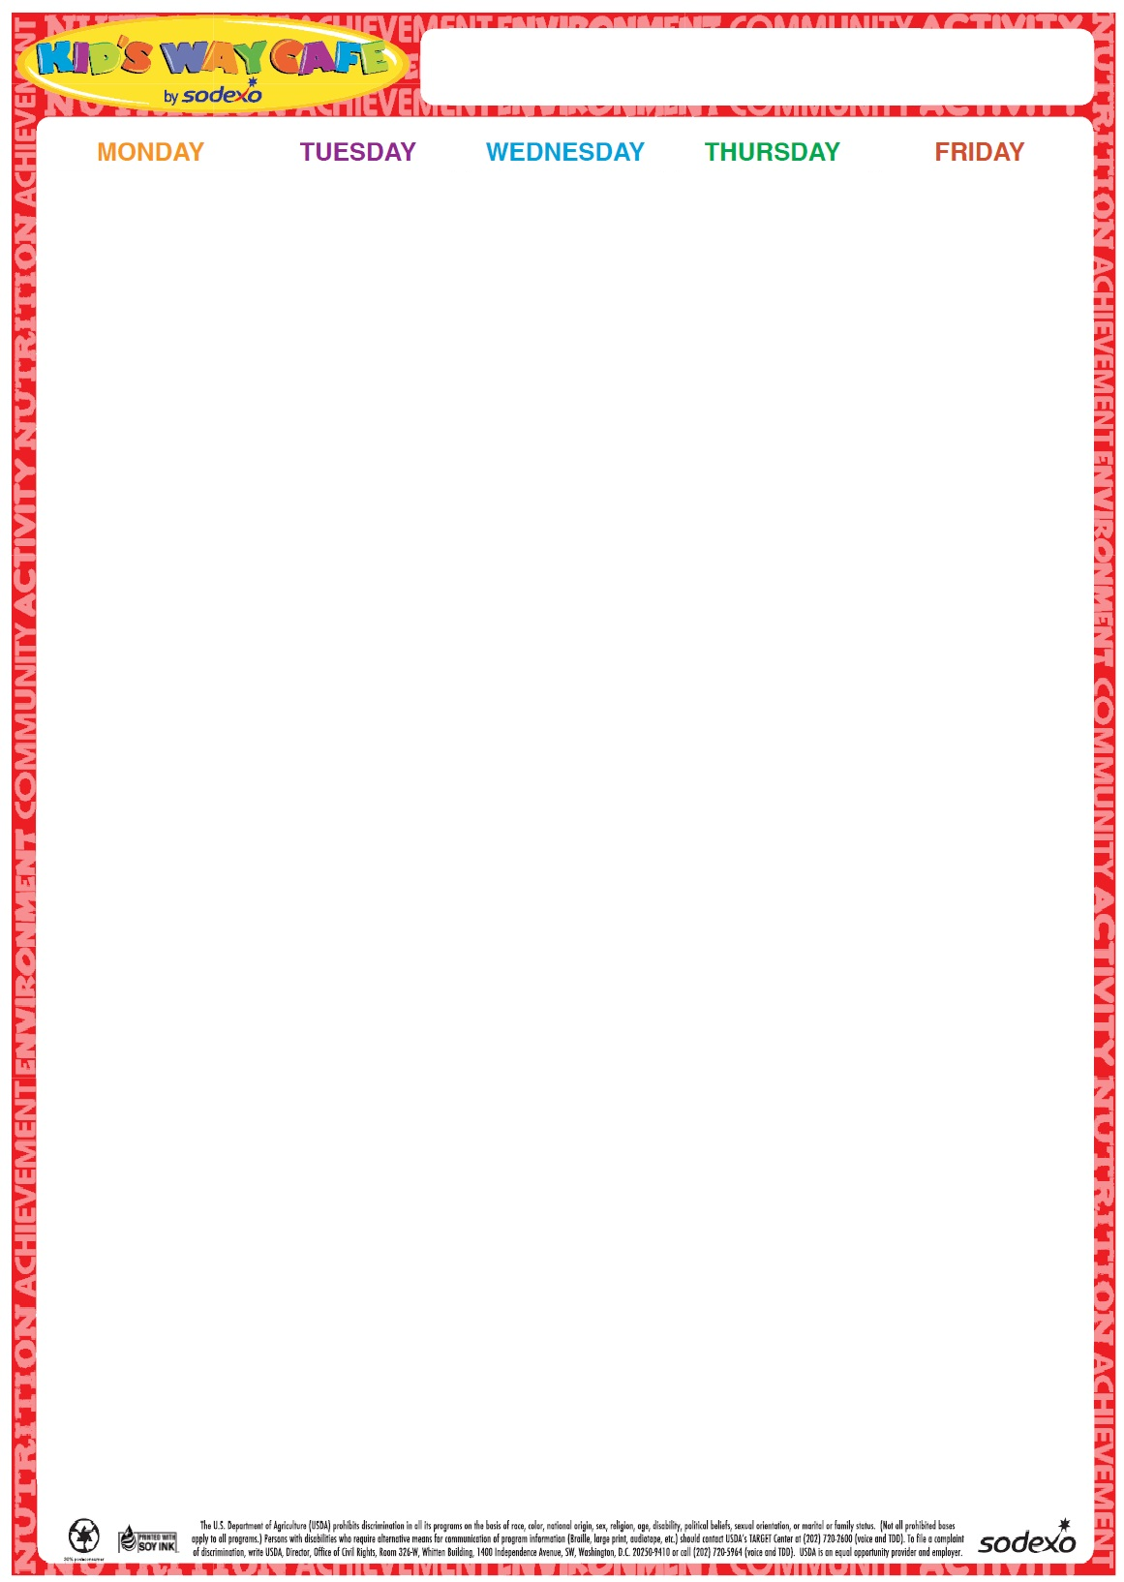

24

Chicken Nuggets

Goldfish crackers

Apple Slices

Roasted Chickpeas

Milk

**25** Corn Dog Broccoli Florets w/Dip

Fruit Milk

**26** Turkey and Cheese on a Grinder

Bean Salad

Fruit

Milk

**27**

Chicken Patty on a Roll

Carrots and Dip

Fruit

Milk

**28**

Cheese Pizza

Garden Salad

Fruit

Milk

**Milk offered Daily-Chocolate or White**

31

Hot Dog on a Roll

Potato Chips & pickles

Corn

Fruit

Milk

**1**

Chicken Salad Sandwich

Teddy Grahams

Baby Carrots w/Dip

Fruit

Milk

**2**

Chicken Nuggets

Goldfish crackers

Apple Slices

Roasted Chickpeas

Milk

**3**

Hamburger on a Roll

Steamed Vegetable Fruit Milk

**4**

Cheese Pizza

Garden Salad

Fruit

Milk

**Milk offered Daily-Chocolate or White**

7

Turkey and Cheese Wrap

Chips

Carrots & Dip

Fruit

Milk

**8**

Italian Combo Grinder

Chips

Fruit

Corn

Milk

**9**

Turkey and Cheese Sandwich on a Roll

Steamed Broccoli Fruit

Milk

10

Chicken Patty on a Roll

Roasted Chickpeas

Fruit Milk

**11**

Cheese Pizza

Garden Salad

Fruit

Milk

**Milk offered Daily-Chocolate or White**

**Milk offered Daily-Chocolate or White**

**2023**

**July/Aug**

Summer Menu