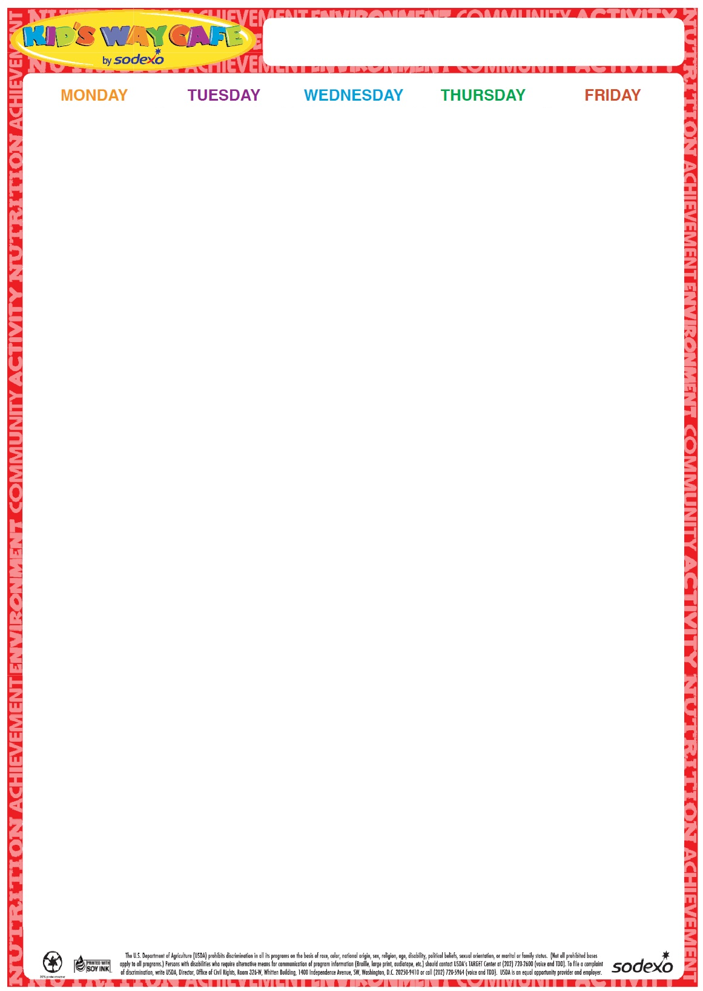

17

Cheeseburger on a Roll

Baby Carrots and ranch dip

Fruit

Milk

**18** Hot Dog on a Roll Broccoli Florets w/Dip

Fruit Milk

**19** Turkey and Cheese on a Grinder

Three Bean Salad

Fruit

Milk

**20**

Chicken Patty on a Roll

Carrots and Dip

Fruit

Milk

**21**

Cheese Pizza

Garden Salad

Fruit

Milk

**Milk offered Daily-Chocolate or White**

24

Hot Dog on a Roll

Potato Chips & pickles

Corn

Fruit

Milk

**25**

Chicken Salad Sandwich w/Buffalo Sauce on the side

Teddy Grahams

Baby Carrots w/Dip

Fruit

Milk

**26**

Chicken Nuggets

Goldfish crackers

Apple Slices

Roasted Chickpeas

Milk

**27**

Hamburger on a Roll

Tater Tots Steamed Vegetable Fruit Milk

**28**

Cheese Pizza

Garden Salad

Fruit

Milk

**Milk offered Daily-Chocolate or White**

1 Grilled Cheese Sandwich

Tomato and Cucumber Salad

Fruit

Milk

**2**

Italian Combo Grinder

Chips

Pickles

Fruit

Baby Carrots

Milk

**3**

Turkey and Cheese Sandwich on a Roll

Steamed Broccoli Fruit

Milk

4

No lunch

**5**

No lunch

**Milk offered Daily-Chocolate or White**

**8**

Fried Dough with Marinara Sauce and 2 Mozzarella Sticks

Cherry Tomatoes

Fruit

Milk

9 Egg, Bacon and Cheese on a Bagel

Tater Tots

Fruit Milk

10

Chicken and Cheese Quesadilla

Salsa

Corn and Black Beans

Fruit

Milk

**11**

Cheeseburger on a Roll

Cucumber and Tomato Salad

Fruit

Milk

12

Cheese Pizza

Garden Salad

Fruit

Milk

**Milk offered Daily-Chocolate or White**

**15**

**Macaroni with Meat Sauce**

**Steamed Broccoli**

**Whole Wheat Dinner Roll  
Fruit**

**Milk**

16

Hot Dog on a Roll

Baked Beans

Fruit

Milk

**17**

**Walking Chicken Nachos with Cheese**

**Rice**

**Corn**

**Fruit**

**Milk**

**18**

Italian Combo Grinder

Chips

Pickles

Fruit

Baby Carrots

Milk

**19**

Cheese Pizza

Garden Salad

Fruit

Milk

**2024**

**June/July**

Summer Menu