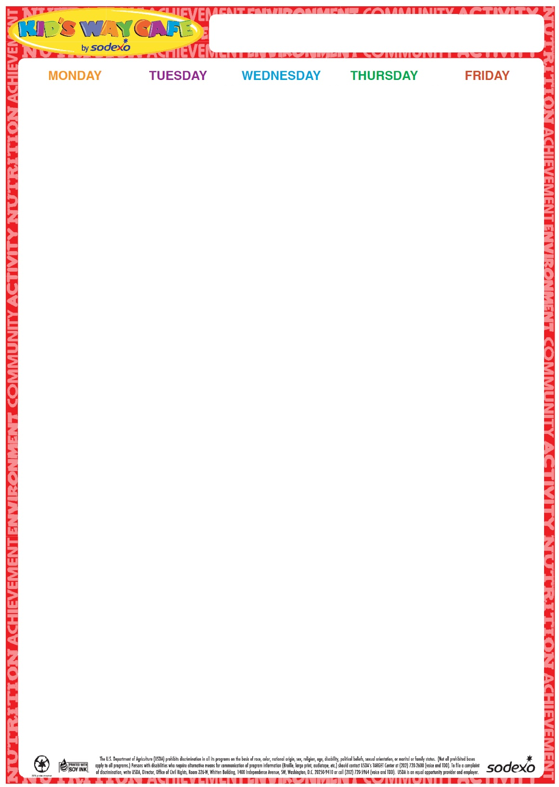

19

**20** All Beef Hot Dog Broccoli Florets w/Dip

Chips

Fruit Milk

**21** Turkey and Cheese on a Grinder

Bean Salad

Fruit

Milk

**22**

Chicken Patty on a Roll

Carrots and Dip

Fruit

Milk

**23**

Cheese Pizza

Garden Salad

Fruit

Milk

**Milk offered Daily-Chocolate or White**

26

Cheeseburger on a Roll

Potato Chips &

Corn

Fruit

Milk

**27**

Turkey and Cheese on a Roll

Teddy Grahams

Baby Carrots w/Dip

Fruit

Milk

**28**

Chicken Nuggets

Goldfish crackers

Apple Slices

Roasted Chickpeas

Milk

**29**

Chicken Patty on a Roll Steamed Vegetable Fruit Milk

**30**

Cheese Pizza

Garden Salad

Fruit

Milk

**Milk offered Daily-Chocolate or White**

3

No Lunch Served

**4**

No Lunch Served

**5**

Turkey and Cheese Sandwich on a Roll

Steamed Broccoli Fruit

Milk

6

Chicken Patty on a Roll

Roasted Chickpeas

Fruit Milk

**7**

Cheese Pizza

Garden Salad

Fruit

Milk

**Milk offered Daily-Chocolate or White**

**10**

Fried Dough with Marinara Sauce and 2 Mozzarella Sticks

Cherry Tomatoes

Fruit

Milk

11 Chicken Nuggets

Tater Tots

Fruit Milk

12

Beefy Nachos

Salsa

Corn and Black Beans

Fruit

Milk

**13**

Cheeseburger on a Roll

Cucumber and Tomato Salad

Fruit

Milk

14

Cheese Pizza

Garden Salad

Fruit

Milk

**Milk offered Daily-Chocolate or White**

**17**

**Macaroni with Meat Sauce**

**Steamed Broccoli**

**Whole Wheat Dinner Roll  
Fruit**

**Milk**

18

Hot Dog on a Roll

Baked Beans

Fruit

Milk

**19**

**Walking Chicken Nachos with Cheese**

**Rice**

**Corn**

**Fruit**

**Milk**

**20**

Italian Combo Grinder

Chips

Pickles

Fruit

Baby Carrots

Milk

**21**

Cheese Pizza

Garden Salad

Fruit

Milk

**2023**

**June/July**

Summer Menu