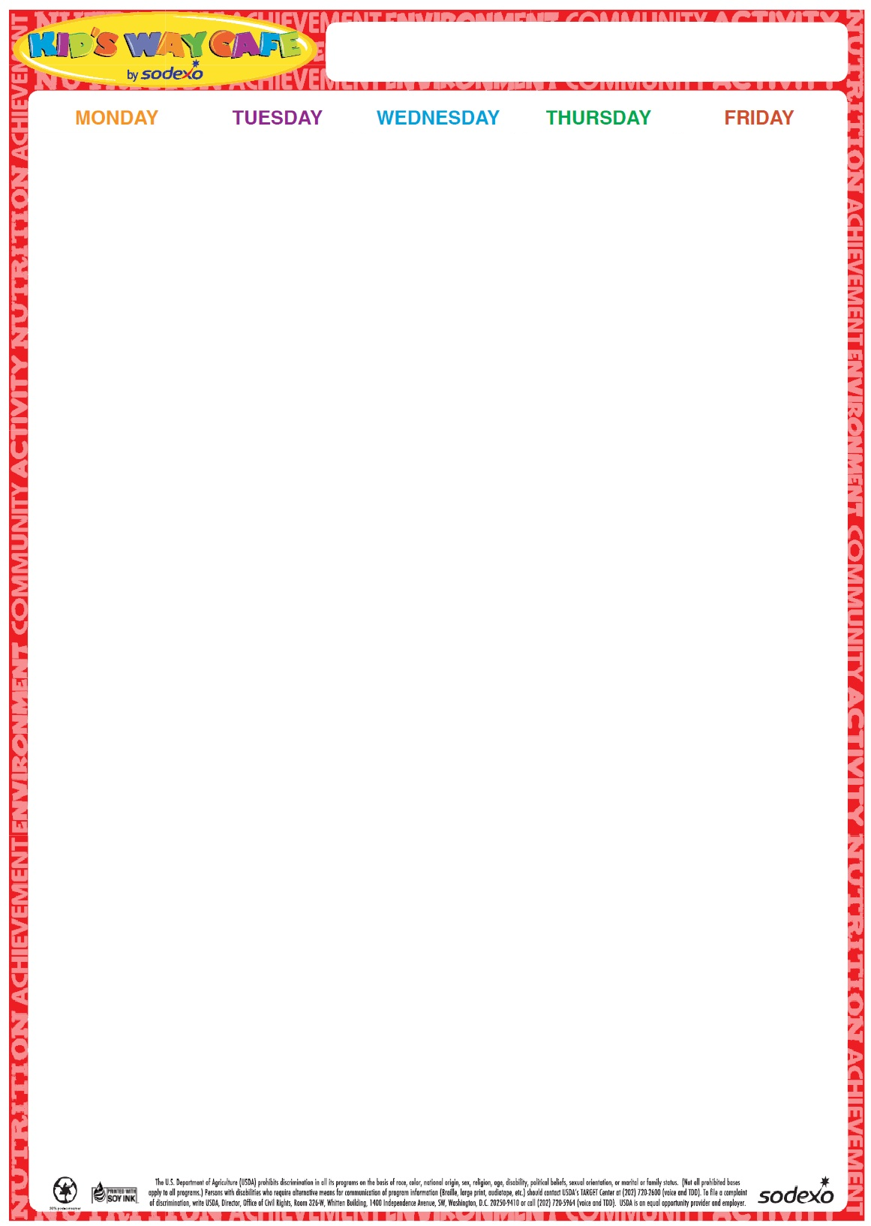portscampmenu

23

Chicken Nuggets

Goldfish crackers

Apple Slices

Roasted Chickpeas

Milk

**24**

French Toast Sticks w/Syrup

Sausage

Baby Carrots w/Dip

Fruit

Milk

**25**

Grilled Cheese

Chips

Apple Slices

Roasted Chickpeas

Milk

**26**

Hamburger on a Roll Tater Tots Steamed Vegetable Fruit Milk

**27**

Cheese Pizza

Garden Salad

Fruit

Milk

**Milk offered Daily-Chocolate or White**

**Milk offered Daily-Chocolate or White**

**Milk offered Daily-Chocolate or White**

**Milk offered Daily-Chocolate or White**

**2024**

**June23-27**

Summer