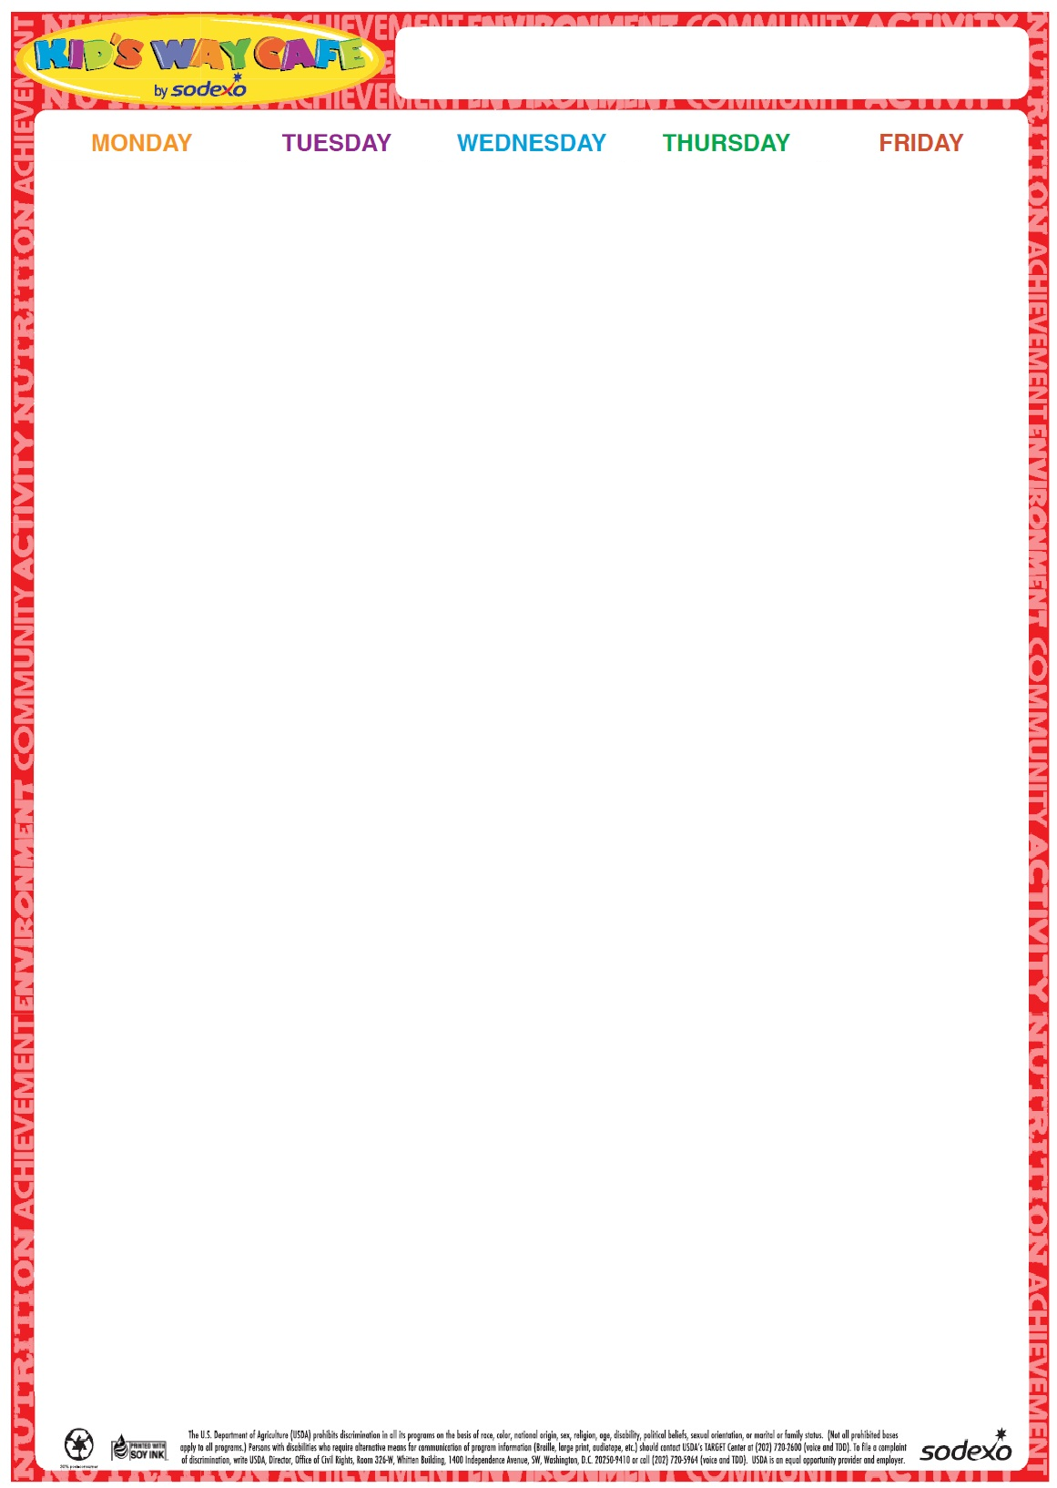portscampmenu

30

Cheeseburger on a Roll

Baby Carrots and ranch dip

Fruit

Milk

**1**

Hot Dog on a Roll Broccoli Florets w/Dip

Fruit Milk

**2**

Turkey and Cheese on a Grinder

Three Bean Salad

Fruit

Milk

**3**

**No Lunch**

**4**

**No Lunch**

**Milk offered Daily-Chocolate or White**

7

Chicken Nuggets

Goldfish crackers

Apple Slices

Roasted Chickpeas

Milk

**8**

French Toast Sticks w/Syrup

Sausage

Baby Carrots w/Dip

Fruit

Milk

**9**

Grilled Cheese

Chips

Apple Slices

Roasted Chickpeas

Milk

**10**

Hamburger on a Roll Tater Tots Steamed Vegetable Fruit Milk

**11**

Cheese Pizza

Garden Salad

Fruit

Milk

**Milk offered Daily-Chocolate or White**

14

Cheeseburger on a Roll

Baby Carrots and ranch dip

Fruit

Milk

**15**

Hot Dog on a Roll Broccoli Florets w/Dip

Fruit Milk

**16**

Turkey and Cheese on a Grinder

Three Bean Salad

Fruit

Milk

17

Pasta with Meatsauce

Tossed Salad

Dinner Roll

Fruit

Milk

**18**

Cheese Pizza

Garden Salad

Fruit

Milk

**Milk offered Daily-Chocolate or White**

**21**

Chicken Nuggets

Goldfish crackers

Apple Slices

Roasted Chickpeas

Milk

22 French Toast Sticks w/Syrup

Sausage

Baby Carrots w/Dip

Fruit

Milk

23

Grilled Cheese

Chips

Apple Slices

Roasted Chickpeas

Milk

**24**

Hamburger on a Roll Tater Tots Steamed Vegetable Fruit Milk

25

Cheese Pizza

Garden Salad

Fruit

Milk

**Milk offered Daily-Chocolate or White**

**28**

Cheeseburger on a Roll

Baby Carrots and ranch dip

Fruit

Milk

29

Hot Dog on a Roll Broccoli Florets w/Dip

Fruit Milk

**30**

Turkey and Cheese on a Grinder

Three Bean Salad

Fruit

Milk

**31**

Pasta with Meatsauce

Tossed Salad

Dinner Roll

Fruit

Milk

**1**

Cheese Pizza

Garden Salad

Fruit

Milk

**2024**

**June/July**

Summer