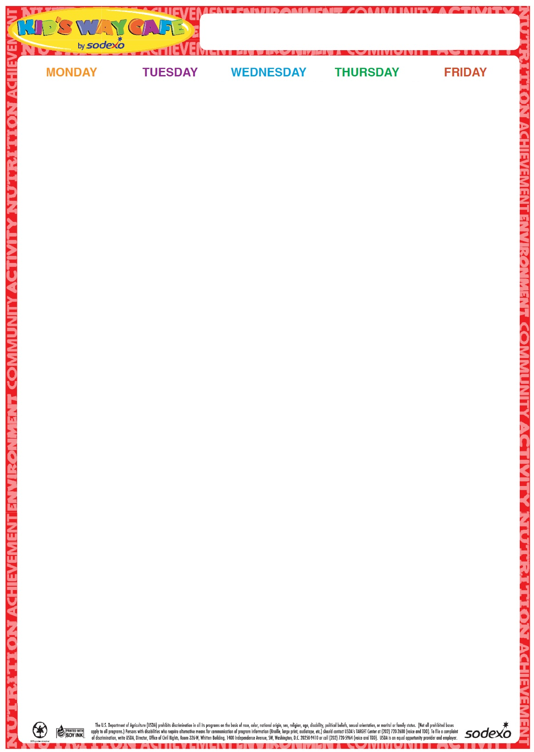portscampmenu

16

Cheeseburger on a Roll

Baby Carrots and ranch dip

Fruit

Milk

**17** Hot Dog on a Roll Broccoli Florets w/Dip

Fruit Milk

**18** Turkey and Cheese on a Grinder

Three Bean Salad

FruitMilk

**19**

Chicken Patty on a Roll

CherryTomatoes

Fruit Milk

**20**

Cheese Pizza

Garden Salad

Fruit Milk

**Milk offered Daily-Chocolate or White**

This is an Equal Opportunity Employer

**Milk offered Daily-Chocolate or White**

**Milk offered Daily-Chocolate or White**

**Milk offered Daily-Chocolate or White**

**2024**

**June**

Summer Sports Camp